Treasure Hunt

Our Forest School Team have created a treasure map for the rest of the school.
Please feel free to use the map to explore Shining Cliff woods, get some fresh air, and find some treasure.

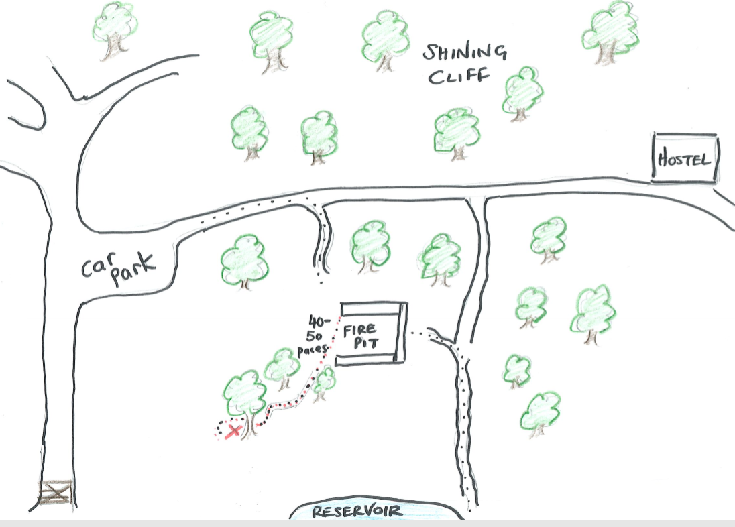
When you find it, you may take something from the treasure chest and leave something in return, and for posterity, enter a log in the logbook. If you take something, leave something of equal or greater value in return also leave the treasure chest as you found it (hidden of course).

Happy hunting!

