National Curriculum Coverage Overview – Class 1
 | Cycle A (2020/21)
 | Autumn |  |  |  | Spring |  |  |  |  |  | Summer
 | Old and New |  |  |  | Homes and Gardens |  |  |  |  |  | Stop. Drop. Roll.
Question | Are old things more important than new things? |  |  |  | Do all children have homes? |  |  |  |  |  | How do communities help in times of need?
Concepts | Curiosity  Tradition  Value  Beauty  Love  Care |  |  |  | Belonging  Community  Diversity  Identity |  |  |  |  |  | Generosity  Kindness  Fear  Friendship  Loyalty
Key Text/s | 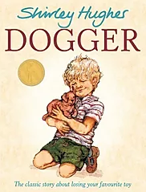  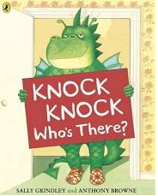  Nursery rhymes |  | 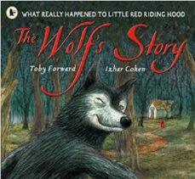  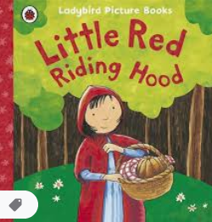 |  | 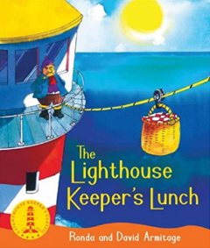  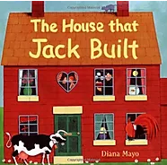  The three litt |  |  | 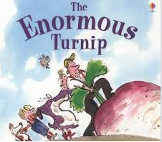  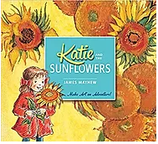 |  |  | 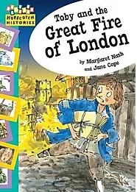  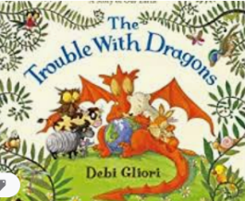 |  |  | 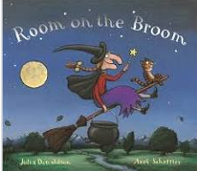  Other stories by Julia Donaldson.
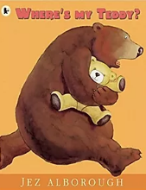  Class Reads | 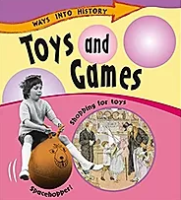  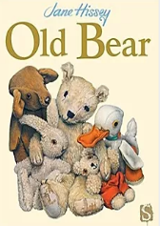 |  | 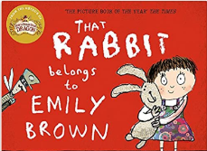  Traditional stories |  | 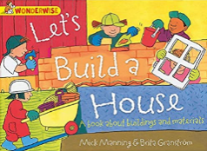  Sign up for Paddingtons  postcards.   |  |  | 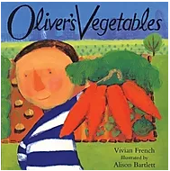 |  |  | 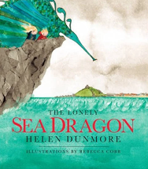 |  |  | Julia Donaldson Stories  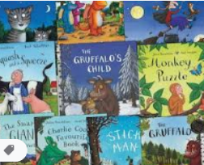
Supporting books/films | Magic Grandad series  Winnie the Pooh books and film  Display books in the reading area with links to toys and teddies. Display old and new books for the children browse. After half term display traditional tales and have CDs for the children to listen to.  Christmas books read and displayed in the lead up to Christmas.  Craft books in the creative area displayed linked to the theme of toys. |  |  |  | Display books in the reading area with links house and gardens in the UK  Display maps and atlases for the children browse.  Easter books read and displayed in the lead up to Easter.  Craft books in the creative area displayed linked to the theme of houses, gardens and Easter. |  |  |  |  |  | Pete’s dragon film.  Display books in the reading area with links to Tudors, Fire of London, dragons.  Display Julia Donaldson books.  Display maps and atlases for the children browse.  Craft books in the creative area displayed linked to the theme fire, London and dragons.
Writing genres | Captions, labels and lists – knock, knock who’s there?  Nursery Rhymes -  Description - Dogger/Toys (Big Book)  Traditional stories with characters that help e.g. Jack and beanstalk, Red Riding Hood…  Play script – Nativity |  |  |  | Descriptions (settings)/Letters and Postcards – The Three Little Pigs  Newspaper reports – The Lighthouse Keepers Lunch  Information text – Enormous turnip/Katie’s Sunflowers  Poetry (Repeating Lines) – The house that Jack Built |  |  |  |  |  | Instructional writing – stop, drop and roll  Diaries – Fire of London  Recounts – Fire of London  Stories by the same author – Julia Donaldson
Science | Animals including humans (Year 1)  Identify, name, draw and label the basic parts of the human body and say which part of the body is associated with each sense. |  |  |  | Plants (Year 1)  Identify and name a variety of common wild and garden plants, including deciduous and evergreen trees  Identify and describe the basic structure of a variety of common flowering plants, including trees.  (Focus on vegetables and herbs) |  |  |  |  |  | Everyday materials (Year 1)  Distinguish between an object and the material from which it is made  Identify and name a variety of everyday materials, including wood, plastic, glass, metal, water, and rock  Describe the simple physical properties of a variety of everyday materials  Compare and group together a variety of everyday materials based on their simple physical properties.
History/Geography | Changes within living memory. Where appropriate, these should be used to reveal aspects of change in national life.  Human and physical geography identify seasonal and daily weather patterns in the United Kingdom and the location of hot and cold areas of the world in relation to the Equator and the North and South Poles  EYFS – Understanding the World - People and communities (30-50 month)  Shows interest in the lives of people who are familiar to them.  Remembers and talks about significant events in their own experience.  Recognises and describes special times or events for family or friends.  Shows interest in different occupations and ways of life. Knows some of the things that make them unique, and can talk about some of the similarities and differences in relation to friends or family.  EYFS – Understanding the World - People and communities (40-60 months)  Looks closely at similarities, differences, patterns and change  EYFS – Understanding the World - People and communities (ELG)  Children talk about past and present events in their own lives and in the lives of family members. They know that other children don’t always enjoy the same things, and are sensitive to this. They know about similarities and differences between themselves and others, and among families, communities and traditions. |  |  |  | Location Knowledge  name, locate and identify characteristics of the four countries and capital cities of the United Kingdom and its surrounding seas  Geographical skills and fieldwork  use world maps, atlases and globes to identify the United Kingdom and its countries, as well as the countries, continents and oceans studied at this key stage  EYFS – Understanding the World - The world (30-50 months)  Comments and asks questions about aspects of their familiar world such as the place where they live or the natural world.  Can talk about some of the things they have observed such as plants, animals, natural and found objects.  Talks about why things happen and how things work.  Developing an understanding of growth, decay and changes over time.  Shows care and concern for living things and the environment.  EYFS – Understanding the World - The world (40-60 months)  Looks closely at similarities, differences, patterns and change.  EYFS – Understanding the World - The world (ELG)  Children know about similarities and differences in relation to places, objects, materials and living things. They talk about the features of their own immediate environment and how environments might vary from one another. They make observations of animals and plants and explain why some things occur, and talk about changes. |  |  |  |  |  | Events beyond living memory that are significant nationally or globally [for example, the Great Fire of London, the first aeroplane flight or events commemorated through festivals or anniversaries]  EYFS – Understanding the World - People and communities (40-60 months)  Looks closely at similarities, differences, patterns and change  EYFS – Understanding the World - People and communities (ELG)  Children talk about past and present events in their own lives and in the lives of family members. They know that other children don’t always enjoy the same things, and are sensitive to this. They know about similarities and differences between themselves and others, and among families, communities and traditions.
Art & Design | To develop a wide range of art and design techniques in using colour, pattern, texture, line, shape, form and space.  Learn about the work of a range of artists, craft makers and designers, describing the differences and similarities between different practices and disciplines, and making links to their own work. [Mackensie Thorpe]  EYFS- PD Moving and Handling (40-60months)  Uses simple tools to effect changes to materials.  Shows a preference for a dominant hand.  Begins to use anticlockwise movement and retrace vertical lines. |  |  |  | Van Gogh’s sunflowers and Kandinsky Trees (Enhancement) |  |  |  |  |  | To develop a wide range of art and design techniques in using colour, pattern, texture, line, shape, form and space.  To use drawing, painting and sculpture to develop and share their ideas, experiences and imagination  [Sculptures of dragons]  Painting – Mixing colours  EYFS PD -Moving and Handling (ELG)  Children show good control and co-ordination in large and small movements. They handle equipment and tools effectively, including pencils for writing.
Design & Technology | Sensory toys for playgroup (Enhancement) |  |  |  | Technical knowledge  Explore pullies, levers and axels (create a pully system)  EYFS PD - Moving and Handling (40-60months)  Uses simple tools to effect changes to materials.  Handles tools, objects, construction and malleable materials safely and with increasing control.  Shows a preference for a dominant hand.  Begins to use anticlockwise movement and retrace vertical lines.  Food technology  Fruit salad/ healthy eating – recipes  Vegetable soup making – forest school skills |  |  |  |  |  | Bread making  Making water squirters using water pressure.
ICT | Fantastic Tales  - DL2 - Use technology safely and respectfully, keeping personal information private; identify where to go for help and support when they have concerns about content or contact on the internet or other online technologies  A is for Algorithm  - CS1 - Understand what algorithms are; how they are implemented as programs on digital devices; and that programs execute by following precise and unambiguous instructions  EYFS Understanding the World - Technology (30-50 months)  Knows how to operate simple equipment, e.g. turns on CD player and uses remote control.  Shows an interest in technological toys with knobs or pulleys, or real objects such as cameras or mobile phones.  Shows skill in making toys work by pressing parts or lifting flaps to achieve effects such as sound, movements or new images. Knows that information can be retrieved from computers |  |  |  | Junior Explorers  - CS1 - Understand what algorithms are; how they are implemented as programs on digital devices; and that programs execute by following precise and unambiguous instructions  - CS2 - Create and debug simple programs  - CS3 - Use logical reasoning to predict the behaviour of simple programs  Pictures Tell a Thousand Words  - DL2 - Use technology safely and respectfully, keeping personal information private; identify where to go for help and support when they have concerns about content or contact on the internet or other online technologies  EYFS Understanding the World - Technology (40-60 months)  Completes a simple program on a computer.  Uses ICT hardware to interact with age-appropriate computer software.  EYFS Understanding the World - Technology (ELG)  Children recognise that a range of technology is used in places such as homes and schools. They select and use technology for particular purposes. |  |  |  |  |  | Crazy Creatures  - CS1 - Understand what algorithms are; how they are implemented as programs on digital devices; and that programs execute by following precise and unambiguous instructions  - CS2 - Create and debug simple programs  - CS3 - Use logical reasoning to predict the behaviour of simple programs  Walking with Dinosaurs  - CS1 - Understand what algorithms are; how they are implemented as programs on digital devices; and that programs execute by following precise and unambiguous instructions  - CS2 - Create and debug simple programs  EYFS Understanding the World - Technology (40-60 months)  Completes a simple program on a computer.  Uses ICT hardware to interact with age-appropriate computer software.  EYFS Understanding the World - Technology (ELG)  Children recognise that a range of technology is used in places such as homes and schools. They select and use technology for particular purposes.
PSHE | Being Healthy  KS1 |  | Bullying Matters  KS1 |  | Exploring Emotion  KS1 |  |  | Relationships  KS1 |  |  | Being Responsible  KS1 |  |  | Difference and Diversity KS1
PSHE  NOTES | - As agreed with CH/RT, EYFS work would be adapted from the Y1 PSHE Matters syllabus as required  - The scheme is based on PSHE Matters. A PSHE Curriculum for Primary Schools in Derbyshire. Further differentiation guidance will be available for September 2020 from Derbyshire County Council  - There is a hard copy of the scheme available and it is also available on the server  - Please see links to books for scheme on server. Most can be found online as videos. Others will be purchased as required. Please look ahead and let PSHE coordinator what books you require (we have funding for this at present (2019/20)  - PSHE must be scheduled each week. Links can be be made to concepts  - Units can be moved around in the particular year’s curriculum plans after careful consideration but all must be covered within the year
RE | 1.1: (Part 1)  Who is a Christian and what do they believe? |  |  | 1.2: (Part 1)  Who is a Muslim and what do they believe? |  | F1  What stories are special and why? |  |  | F3  Which places are special and why? | F4  Which times are special and why? |  |  | 1.6: (Part 1)  How and why do we celebrate special and sacred times?
RELLIGION | Christians |  |  | Muslims |  | Christians, Hindus and Muslims |  |  | Christians and Muslims | Christians, Muslims and Jewish people |  |  | Christians, Muslims or Jewish people
RE  NOTES | - To ensure full coverage and progression, please do not move units between cycles. Careful consideration should be given before moving units within the year as each unit develops knowledge learnt earlier in the year  - All RE units have emerging, expected and exceeding learning outcomes which will help with differentiation based on year groups and/or ability as required.  - F1 onwards are FS and 1.1 onwards are year 1  - Part 2 will follow on in Class 2 so it is important that Part 1 is done in Class 1. Further notes on Part 2 fits in will be given in Class 2 plans.
Music | Hey You! (Y1) | Rhythm in the Way We Walk and Banana Rap (Y1) |  |  | In The Groove (Y1) |  | Round and Round (Y1) |  |  |  | Your Imagination (Y1) | Reflect, Rewind, Replay (Y1)
EYFS Phonics
  s a t p
  n i
  m g
  b p
  c k l qu
  o e u
  v d r
  f h z w y
  ch sh j x
  th (v) th ng
  CCVC CVCC
  CCVCC CVVCC CCVVC
  CVCC CCVC Consolidation
  CVCC CVCC CCVCC Consolidation
  CVCC CCVC CCVCC HFW Consolidation
  CVCC CCVC CCVCC Review
  Compound Words
  CVCC CCVC CCVCC
  Review
  Compound Words
  CVCC CCVC CCVCC
  Review
  Compound Words
  oo
  ar
  oo (u)
  ow
  ee
  ur
  ai
  or
  oa
  er
  igh
  air
Year 1 Phonics
  ff ss zz | ll ck | nk
  tch | ve | ai
  oi | ay | oy
  suffixes s/es | assess | a-e
  e-e | i-e | o-e
  u-e | u-e | ar
  g | suffix ing/ed | suffix ing/ed
  Assess | ea | ea
  er | ir | ur
  oa | oo (u) | oo
  Suffix er /est | Assess | oe
  ou | ow | ow
  ue |  | ue |  | ew
  ew |  | i before  y i e |  | Assess
  ie |  | ie |  | igh
  or |  | ore |  | aw
  au |  | air |  | Prefix un
  Assess |  | ear  (long E) |  | ear (air)
  are |  | y |  | ph
  wh |  | e |  | o
  Assess | Review ff ll ss zz ck |  | Review  nk |  | Review  tch
  Review  ve | Review  ai |  | Review  oi |  | Review  ay
  Review  oy | Review  a-e |  | Review  e-e |  | Review  i-e
  Review o-e | Review  u-e |  | Review  u-e |  | Review  ar
  Phonics Screen
  Review  ee | Review ea |  | Review ea |  | Review er
  Review  ir | Review  ur |  | Review  oa |  | Review  oo (u)
  Review  oo | Review  oe |  | Review  ou |  | Review  ow
  Review  ow | Review  ue |  | Review  ue |  | Review  ew
  Review  ew | Review  ie |  | Review  ie |  | Review  igh
  Review or | Review ore |  | Review aw |  | Review au
  Review air | Review ear (long E) |  | Review ear (air) |  | Review are
  Review y | Review ph |  | Review wh |  | Review e
  Review o |  | 2 Syllable Words |  | Compound Words
  Numbers |  | Contractions
  Days |  | Colours |  | Months

 | Cycle B (2021/22)
 | Autumn |  |  |  | Spring |  |  | Summer
 | One small step. |  |  |  | Up, up and away! |  |  | On the farm.
Question | Are we alone? |  |  |  | If we had wings could we fly? |  |  | Is a cow more important than a caterpillar?
Concepts | Curiosity  Friendship  Empathy  Diversity  Determination |  |  |  | Dreams  Freedom  Justice  Power  Transformation |  |  | Loyalty  Appreciation  Creativity  Pride  Care
Key Text/s | 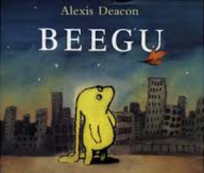  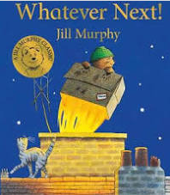 |  |  | 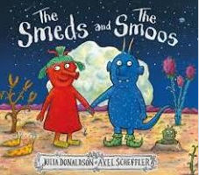  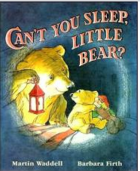 | 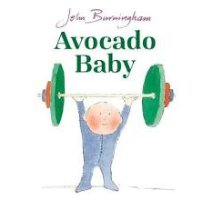  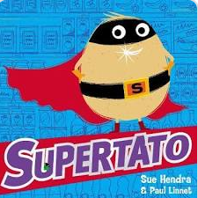 | 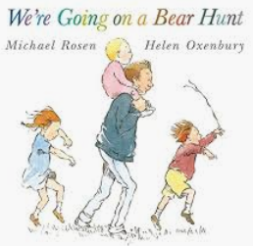  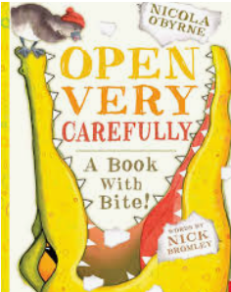 |  | 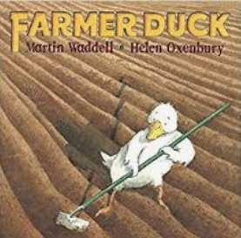  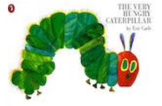 |  | 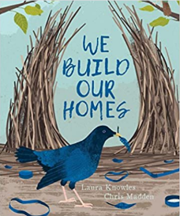  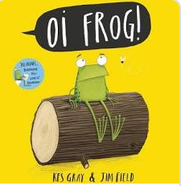
Class Reads | 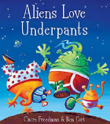  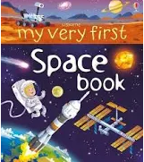  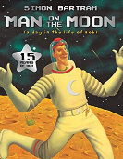 |  |  | 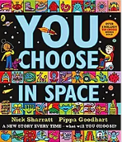  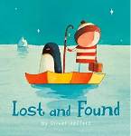  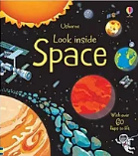 | 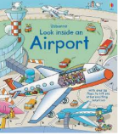  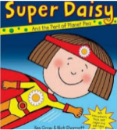  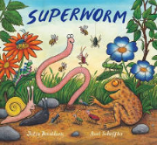 | 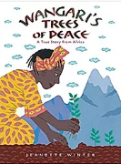  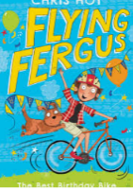  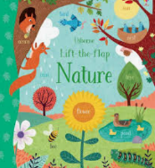 |  | 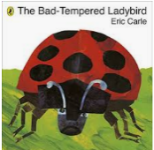  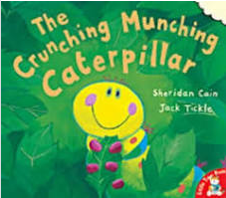  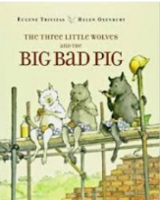 |  | 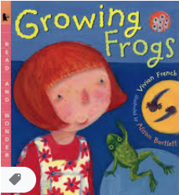  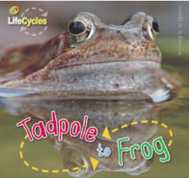
Supporting books/films | Non-fiction books about space and light  Display books in the reading area with links to space, aliens, light and festivals.  Christmas books read and displayed in the lead up to Christmas.  Craft books in the creative area displayed linked to the theme of space and festivals. |  |  |  | Non-fiction books about flight.  Display books in the reading area with links to flying, balloons, superpowers.  Easter read and displayed in the lead up to Easter.  Film – Up! |  |  | Non-fiction books about farms, minibeasts, animals.  Display books in the reading area with links to farms, animals and minibeasts.  Film – Charlotte’s Web/Babe
Writing genres | Beegu - Captions, lists and labels  Whatever next? - lists, drama  Rhymes – Smeds and Smoos  Can’t you sleep Little Bear? – repeating phrases/Speech bubbles  Play script - Nativity |  |  |  | Instructions-(Open very carefully) Favourite recipes/Healthy eating  Fantasy Stories – Avocado Baby/Supertato  Superhero Silly poetry |  |  | xplanation text - The very hungry caterpillar/life cycles (frogs)  Glossary – Alphabetical order  Familiar setting – the Bad Tempered Ladybird  Poetry - Oi Frog rhymes!
Science | Seasonal Changes (Year 1)  observe changes across the four seasons  observe and describe weather associated with the seasons and how day length varies. |  |  |  | Plants (Year 1)  identify and name a variety of common wild and garden plants, including deciduous and evergreen trees  identify and describe the basic structure of a variety of common flowering plants, including trees.  (flowering plants and trees) |  |  | Animals including humans (Year 1)  identify and name a variety of common animals including fish, amphibians, reptiles, birds and mammals  identify and name a variety of common animals that are carnivores, herbivores and omnivores Science – key stages 1 and 2 8 Statutory requirements  describe and compare the structure of a variety of common animals (fish, amphibians, reptiles, birds and mammals, including pets)
History/Geography | Investigate the lives of significant individuals in the past who have contributed to national and international achievements. Some should be used to compare aspects of life in different periods – Neil Armstrong/Tim Peake  EYFS – Understanding the World (People and communities 30-50)  Shows interest in the lives of people who are familiar to them.  Remembers and talks about significant events in their own experience.  Recognises and describes special times or events for family or friends.  Shows interest in different occupations and ways of life. Knows some of the things that make them unique, and can talk about some of the similarities and differences in relation to friends or family.  EYFS – Understanding the World (People and communities 40-60)  Looks closely at similarities, differences, patterns and change  EYFS – Understanding the World (People and communities ELG)  Children talk about past and present events in their own lives and in the lives of family members. They know that other children don’t always enjoy the same things, and are sensitive to this. They know about similarities and differences between themselves and others, and among families, communities and traditions. |  |  |  | Geographical skills and fieldwork  use simple compass directions (North, South, East and West) and locational and directional language [for example, near and far; left and right], to describe the location of features and routes on a map.  Geographical skills and fieldwork  use aerial photographs and plan perspectives to recognise landmarks and basic human and physical features; devise a simple map; and use and construct basic symbols in a key  Geographical skills and fieldwork  use simple fieldwork and observational skills to study the geography of their school and its grounds and the key human and physical features of its surrounding environment.  Events beyond living memory that are significant nationally or globally [for example, the Great Fire of London, the first aeroplane flight or events commemorated through festivals or anniversaries]  EYFS – Understanding the World (The world 30-50)  Comments and asks questions about aspects of their familiar world such as the place where they live or the natural world.  Can talk about some of the things they have observed such as plants, animals, natural and found objects.  Talks about why things happen and how things work.  Developing an understanding of growth, decay and changes over time.  Shows care and concern for living things and the environment.  EYFS – Understanding the World (The world ELG)  Children know about similarities and differences in relation to places, objects, materials and living things. They make observations of animals and plants and explain why some things occur, and talk about changes. |  |  | Place knowledge  understand geographical similarities and differences through studying the human and physical geography of a small area of the United Kingdom,
Art & Design | To develop a wide range of art and design techniques in using colour, pattern, texture, line, shape, form and space.  Learn about the work of a range of artists, craft makers and designers, describing the differences and similarities between different practices and disciplines, and making links to their own work. [Andy Warhol Pop-art]  EYFS PD (Moving and Handling (40-60months)  Uses simple tools to effect changes to materials.  Shows a preference for a dominant hand.  Begins to use anticlockwise movement and retrace vertical lines. |  |  |  |  |  |  | To develop a wide range of art and design techniques in using colour, pattern, texture, line, shape, form and space.  To use drawing, painting and sculpture to develop and share their ideas, experiences and imagination  [Recycled materials – creating minibeasts]  EYFS PD (Moving and Handling (ELG)  Children show good control and co-ordination in large and small movements. They handle equipment and tools effectively, including pencils for writing.
Design & Technology | Technical Knowledge  Explore and use mechanisms [for example, levers, sliders, wheels and axles], in their products.  [Moon buggy – axles and wheels – Enhancement]  EYFS PD (Moving and Handling (40-60months)  Handles tools, objects, construction and malleable materials safely and with increasing control.  Shows a preference for a dominant hand.  Begins to use anticlockwise movement and retrace vertical lines. |  |  |  | Make  Select from and use a wide range of materials and components – Textiles  [Superhero capes and masks] |  |  | Technical knowledge  Build structures, exploring how they can be made stronger, stiffer and more stable  [Bird houses – wood]  EYFS PD (Moving and Handling (ELG)  Children show good control and co-ordination in large and small movements. They handle equipment and tools effectively, including pencils for writing.
ICT | Young Investigators  - DL2 – Use technology safely and respectfully, keeping personal information private; identify where to go for help and support when they have concerns about content or contact on the internet or other online technologies  - IT 1 - Use technology purposefully to create, organise, store, manipulate and retrieve digital content  Let’s Celebrate  - DL1 - Recognise common uses of information technology beyond the school  - IT 1 - Use technology purposefully to create, organise, store, manipulate and retrieve digital content |  |  |  | Our Local Area (Out and About)  - DL2 - Use technology safely and respectfully, keeping personal information private; identify where to go for help and support when they have concerns about content or contact on the internet or other online technologies  - IT 1 - Use technology purposefully to create, organise, store, manipulate and retrieve digital content  Art Attack  - DL1 - Recognise common uses of information technology beyond the school  - IT 1 - Use technology purposefully to create, organise, store, manipulate and retrieve digital content |  |  | Ready, Steady, GO!  - CS1 - Understand what algorithms are; how they are implemented as programs on digital devices; and that programs execute by following precise and unambiguous instructions  - CS2 - Create and debug simple programs  - IT 1 - Use technology purposefully to create, organise, store, manipulate and retrieve digital content  App Attack  - DL1 - Recognise common uses of information technology beyond the school  - IT 1 - Use technology purposefully to create, organise, store, manipulate and retrieve digital content
PSHE | Being Healthy  KS1 |  | Difference and Diversity KS1 |  | Exploring Emotion  KS1 |  | Relationships  KS1 | Being Responsible  KS1 | Bullying Matters  KS1
PSHE  NOTES | - As agreed with CH/RT, EYFS work would be adapted from the Y1 PSHE Matters syllabus as required  - The scheme is based on PSHE Matters. A PSHE Curriculum for Primary Schools in Derbyshire. Further differentiation guidance will be available for September 2020 from Derbyshire County Council  - There is a hard copy of the scheme available and it is also available on the server  - Please see links to books for scheme on server. Most can be found online as videos. Others will be purchased as required.  - PSHE must be scheduled each week. Links can be be made to concepts  - Units can be moved around in the particular year’s curriculum plans after careful consideration but all must be covered within the year
RE | F6  What is special about our world? |  | F5  Where do we belong? |  | F2  Which people are special and why? |  | 1.7  What does it mean to below to a faith community? | 1.5  What makes some places sacred?
RE | Christians, Muslims and Jewish people |  | Christians, Hindus and Muslims |  | Christians, Muslims and Jewish people |  | Christians, Muslims and Jewish people | Christians, Muslims and/or Jewish people
RE NOTES | - To ensure full coverage and progression, please do not move units between cycles. Careful consideration should be given before moving units within the year as each unit develops knowledge learnt earlier in the year  - All RE units have emerging, expected and exceeding learning outcomes which will help with differentiation based on year groups and/or ability as required.  - F1 onwards are FS and 1.1 onwards are year 1
Music | Hey You! (Y1) | Rhythm in the Way We Walk and Banana Rap (Y1) |  |  | In The Groove (Y1) | Round and Round (Y1) |  | Your Imagination (Y1) |  | Reflect, Rewind, Replay (Y1)
RE  NOTES | - To ensure full coverage and progression, please do not move units between cycles. Careful consideration should be given before moving units within the year as each unit develops knowledge learnt earlier in the year  - All RE units have emerging, expected and exceeding learning outcomes which will help with differentiation based on year groups and/or ability as required.  - F1 onwards are FS and 1.1 onwards are year 1  - Part 2 will follow on in Class 2 so it is important that Part 1 is done in Class 1. Further notes on Part 2 fits in will be given in Class 2 plans.
Music | Hey You! (Y1) | Rhythm in the Way We Walk and Banana Rap (Y1) | In The Groove (Y1) | Round and Round (Y1) | Your Imagination (Y1) | Reflect, Rewind, Replay (Y1)
EYFS Phonics
  s a t p
  n i
  m g
  b p
  c k l qu
  o e u
  v d r
  f h z w y
  ch sh j x
  th (v) th ng
  CCVC CVCC
  CCVCC CVVCC CCVVC
  CVCC CCVC Consolidation
  CVCC CVCC CCVCC Consolidation
  CVCC CCVC CCVCC HFW Consolidation
  CVCC CCVC CCVCC Review
  Compound Words
  CVCC CCVC CCVCC
  Review
  Compound Words
  CVCC CCVC CCVCC
  ReviewCompound Words
  oo
  ar
  oo (u)
  ow
  ee
  ur
  ai
  or
  oa
  er
  igh
  air
Year 1 Phonics
  ff ss zz | ll ck | nk
  tch | ve | ai
  oi | ay | oy
  suffixes s/es | assess | a-e
  e-e | i-e | o-e
  u-e | u-e | ar
  g | suffix ing/ed | suffix ing/ed
  Assess | ea | ea
  er | ir | ur
  oa | oo (u) | oo
  Suffix er /est | Assess | oe
  ou | ow | ow
  ue |  | ue |  | ew
  ew |  | i before  y i e |  | Assess
  ie |  | ie |  | igh
  or |  | ore |  | aw
  au |  | air |  | Prefix un
  Assess |  | ear  (long E) |  | ear (air)
  are |  | y |  | ph
  wh |  | e |  | o
  Assess | Review ff ll ss zz ck |  | Review  nk |  | Review  tch
  Review  ve | Review  ai |  | Review  oi |  | Review  ay
  Review  oy | Review  a-e |  | Review  e-e |  | Review  i-e
  Review o-e | Review  u-e |  | Review  u-e |  | Review  ar
  Review  ee | Review ea |  | Review ea |  | Review er
  Review  ir | Review  ur |  | Review  oa |  | Review  oo (u)
  Review  oo | Review  oe |  | Review  ou |  | Review  ow
  Review  ow | Review  ue |  | Review  ue |  | Review  ew
  Review  ew | Review  ie |  | Review  ie |  | Review  igh
  Review or | Review ore |  | Review aw |  | Review au
  Review air | Review ear (long E) |  | Review ear (air) |  | Review are
  Review y | Review ph |  | Review wh |  | Review e
  Review o |  | 2 Syllable Words |  | Compound Words
  Numbers |  | Contractions
  Days |  | Colours |  | Months

