Autumn Term Newsletter

Welcome back. I hope you have had a wonderful holiday with lots of memory making and fun! Now we are back at school for a new school year, here is a newsletter to read about the upcoming half term. If you have any questions or concerns, feel free to come and have a chat. Thanks, Miss Rouke.

Topic

Our topic for the first half term will be ‘Crime and Punishment’. This will involve learning about crime and punishment through the ages (Anglo-Saxons, Tudors, Victorian and modern day). This topic aims to inform the children of how history has evolved and offers an interesting topic to use cross-circularly. Our trip to the Houses of Parliament will introduce the importance of the government in England and how it was developed over time.

English
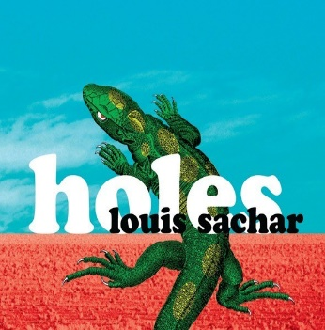
Our English work will be linked to ‘Crime and Punishment’, which will provide opportunities to write in a range of styles and genres (narrative, biographies, poetry, letters, newspapers, etc.). Spelling, punctuation and grammar (SPAG) will be taught weekly, this will involve understanding and applying the variety of terminology that the children will learn. Our class book will be ‘Holes’ by Louis Sachar this half term, we will read it as a class and some lessons will be based around it. If your child has a copy, they are more than welcome to bring it in and read along.
A weekly spelling test will continue every Wednesday afternoon, the new spellings will also be handed out on Wednesday. The spellings will be available on Class 3’s page on the school website. Please encourage your child to practice spellings a few times each week.

Maths
Across this half term, we will be covering: place value; addition; subtraction; multiplication and division. To support your child’s learning at home, please continue to use MyMaths and Times Tables Rockstars. Homework will be set weekly, the MyMaths homework will link to the work we have done in that week.


Science
Our science topic will be ‘the human body’, this will be linked to the ‘Crime and Punishment’ topic through a forensic theme. The science topic aims to be practical and hands on! We are very lucky that Mrs. Horner will continue to teach extra science sessions in small groups to provide interactive and engaging science sessions that will stretch the children’s understanding and knowledge.

R.E
Our topic this half term will be ‘What are the deeper meanings of festivals?’ Therefore, we will be looking at a range of festivals in a variety of religions to learn about the importance of festivals.


Art/DT and Computing

Once again, Art and DT will link to ‘Crime and Punishment’. The children will create master pieces in the style of Hans Holbein and J.M.W Turner, these will represent the era covered in that week e.g. Victorian. We will also create ‘mug shots’, 3D prison designs and many more projects throughout the topic. In computing, we will be looking at online safety to emphasise the importance of being aware and safe on the internet. We will also develop skills on Word and PowerPoint, along with editing pictures in a ‘Photoshop’ style and many other computing skills will be developed.

Languages, Music and P.E
The children will learn German with Mrs. Ince on a Thursday afternoon. This will continue to build upon the German language skills they have been working on through the years they have spent with Mrs. Ince. Brass will be on Wednesday afternoons with Mr. Jones. The year 5 and 6’s will continue to build upon their talents through learning new music and more complex skills. The year 4’s will begin their journey of learning a brass instrument, this will be a great next step now that they have mastered many fundamental musical skills on the recorders. Finally, P.E. will continue to take place on a Friday afternoon. Please be aware that as the weather turns chilly, the children need long bottoms and a jumper.

Homework
As mentioned above, there will be weekly spellings, MyMaths and Times Tables Rockstars. We will also have a homework book that will have a weekly activity for the children to do, this activity will vary from week to week. It will be due in on a Wednesday and new homework will be sent out on a Friday. Please continue to read regularly with your child as it helps to develop their English skills massively; it will boost their comprehension, word reading and widen their vocabulary.

