Spring Term 1 Newsletter
Happy New Year! This newsletter is to let you know what we have in store for the next half term! If you have any questions feel free to come and see me!
Thanks, Miss Rouke.

Topic
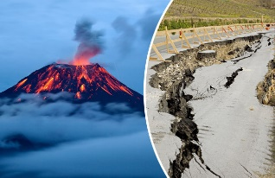
Our topic for the first half term will be ‘Let’s Cause an Eruption’. This will be a topic full of learning through fun and hands-on activities! We will begin the half term by looking into the structure of the Earth and how the tectonic plates create earthquakes and volcanoes. Throughout the half term, we will learn about: the ‘Ring of Fire’; major volcanic eruptions and earthquakes; key terminology; how to build an earthquake-proof building and we will build a model of a volcano.

English
Where possible, our English work will be linked to our topic ‘Let’s Cause an Eruption’ or our Science topic ‘Forces’. There will be opportunities to write in a range of styles and genres. Spelling, punctuation and grammar (SPAG) will be taught every day, this will involve understanding and applying a variety of terminology that the children will learn, along with consolidating terms we have already learned.
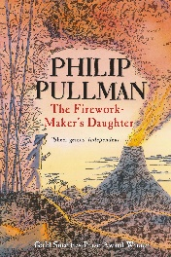
Our class book will be ‘The Firework-Makers Daughter’ by Phillip Pullman this half term, we will read it as a class and our whole class guided reading will be based around it. If your child has a copy, they are more than welcome to bring it in and read along.
A weekly spelling test will continue every Wednesday afternoon, the new spellings will also be handed out on Wednesday. The spellings will be available on Spelling Shed, we are still trialling a different group of spellings, so any feedback on the new spellings is welcome.
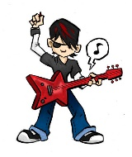
Maths
Across this half term, we will be covering: decimals, fractions, percentages, statistics and more. To support your child’s learning at home, please continue to use MyMaths and Times Tables Rockstars, the homework will be set weekly.

Science
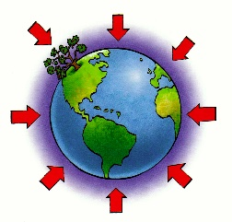
Our Science topic will be ‘Forces’ this will be linked to Volcanoes and Earthquakes where possible. We will learn the theoretical aspect of forces alongside carrying out a range of investigations. These investigations will involve testing out different types of forces such as friction, air resistance and water resistance. There will also be investigations into how mechanisms work. Mrs. Horner will continue to teach extra science sessions in small groups to provide interactive and engaging science sessions that will stretch the children’s understanding and knowledge. These sessions will also link to Forces.

R.E.
In this half term, we will be looking into the value of sacred places for different religions. This will involve researching and learning about the River Ganges, Bodh Gaya, Temple Mount and The Golden Temple.


Art/DT
We will learn all about Jackson Pollock- who he was; where he came from; what he did and why he was famous. Then we will then try to capture his style of abstract expressionist ‘drip’ painting.

Computing

In Computing, we will be creating a news report about a fictional earthquake or volcanic eruption! This will involve planning, filming, editing and publishing our news reports. I am excited to see the wonderful technological creations that the children will make!

Music and P.E
As you have all seen, Class 3 are doing brilliantly at learning their brass instruments. Brass will continue to be on Wednesday afternoons with Mr. Jones and Miss Arnold. P.E. will continue to take place on a Friday afternoon. Please be aware that as the weather turns colder, the children need long bottoms and a jumper.
Homework – A reminder!
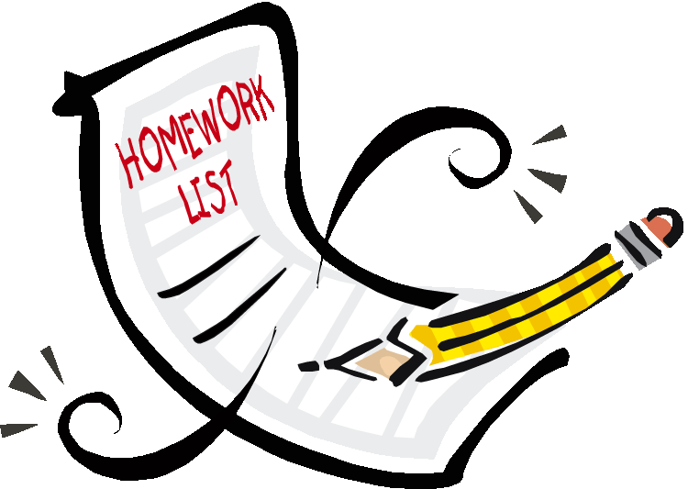
There are weekly spellings, MyMaths and Times Tables Rockstars tasks to complete. We also have a homework book that will have a weekly activity for the children to do, this activity will vary from week to week. It will be due in on a Wednesday and new homework will be sent out on a Friday. Please continue to read regularly with your child as it helps to develop their English skills massively; it will boost their comprehension, word reading and widen their vocabulary.

