Spring Term 2 Newsletter
Here is our next newsletter to keep you up to date with Class 3’s activities and learning. We are lucky enough to have Miss Moran in our class for this half term. She is on a teaching placement from the University of Derby. If you have any questions about this half term, please don’t hesitate to come and see any adults in Class 3.
Thanks, Miss Rouke
Topic

Our topic for this half term will be ‘Bright Ideas’. This will focus on learning about inventors and their inventions. We are excited to learn about Benjamin Franklin, Sir Humphrey Davey, Rowland Emett and more! We will create art based around inventors and create a timeline of history through inventions.

English
Where possible, our English work will be linked to our topic ‘Bright Ideas’ or our Science topic ‘Electricity. The children will have opportunity to write fiction and non-fiction pieces. They will also spend lots of time looking at spelling, punctuation and grammar (SPAG) terms. The children will continue to have spelling tests on Wednesday afternoons.
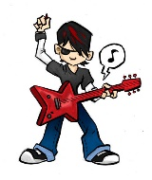
Maths
Across this half term we will be learning about measure, capacity, volume, shape, position and direction. They will still have homework set on MyMaths and they can log on to Timetables Rockstars to practice their tables.

Science
Our Science topic will be ‘Electricity’. This will link perfectly with our topic of ‘Bright Ideas’. We will be learning about circuits and how they work. We will investigate how adding extra items to a circuit will impact how loudly a buzzer will buzz or how brightly a light will shine. Our trip will link to electricity, as we will go to Eureka! on 12th March 2019, during Science week, to learn all about energy. Have a look at the website for more information https://www.eureka.org.uk/

R.E./P.S.H.E
In R.E. this half term we will be focusing on debating around the question ‘Does religion make for a fair world?’ The children will learn how to debate fairly and point their point across. Then they will debate their view on this matter. In P.S.H.E, they will be working with Miss Moran on boosting their self-confidence and having a growth mind set.

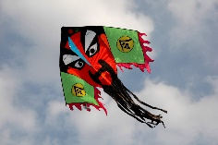
Art/DT
This half term, the children will create their own kites, just like the Chinese invented over 2,000 years ago! They will also use circuit equipment to create a moving toy. We will then pitch the designs in the style of Dragon’s Den to other classes.

Computing
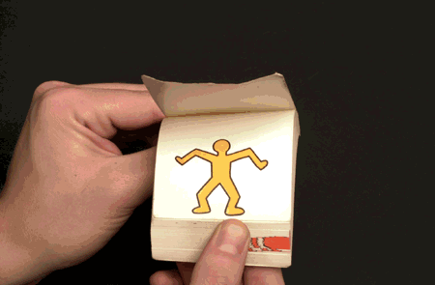
In computing, we will be focusing on learning about how animations work. We will make flip books and then translate this learning on to the computer.

Music and P.E
Brass will continue to be on Wednesday afternoons with Mr. Jones and Miss Arnold. P.E. will continue to take place on a Friday afternoon. Please be aware that the weather can still be chilly, please send your children with a jumper and long bottoms.

Homework – A reminder!

There are weekly spellings, MyMaths and Times Tables Rockstars tasks to complete. We also have a homework book that will have a weekly activity for the children to do, this activity will vary from week to week. It will be due in on a Wednesday and new homework will be sent out on a Friday. Please continue to read regularly with your child as it helps to develop their English skills massively; it will boost their comprehension, word reading and widen their vocabulary.

