Summer Term 1 Newsletter
I hope you have had a lovely break and eaten lots of Easter chocolate! We are back in the swing of things straight away this term. If you have any questions about what is coming up, feel free to come and see any adults in Class 3.
Thanks, Miss Rouke

Topic
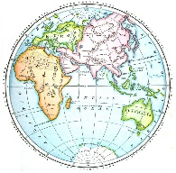
Our topic for this half term will be ‘Time to Reflect’. The topic will focus on learning about the different parts of the Earth’s layout and how time zones are different. The children will learn lots of new vocabulary such as: latitude, longitude, Equator, Northern Hemisphere, Southern Hemisphere, the Tropics of Cancer and Capricorn, Arctic and Antarctic Circle, the Prime/Greenwich Meridian and time zones (including day and night). This will link well with our Science topic of Light.
English
Where possible, our English work will be linked to our topic - Time to Reflect or our Science topic - Light. The children will have opportunity to write fiction and non-fiction pieces. They will also spend lots of time looking at spelling, punctuation and grammar (SPAG) terms. The children will continue to have spelling tests on Wednesday afternoons.

Maths
Over the half term, we will be learning about statistics, graphs and coordinates. We will also revise all areas that we have covered this year. WE will continue to make maths as practical and fun as possible! Don’t forget to log in to Times Table Rockstars to practice your times tables.
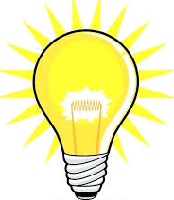
Science
In Science our topic will be Light. We will be learning about how light travels, how we see light and how shadows are formed. This will, once again, involved practical activities to apply the theory that we have learned over the half term. Where possible, this will be linked to our general topic – Time to Reflect.

R.E./P.S.H.E
In R.E. this half term we will be focusing on debating around the question ‘What do different people believe about God?’[0p We will use the skills that we have learned last half term to fairly discuss this question, after we have researched the information thoroughly. We will also look at the question from other perspectives such as, ‘What would I do if I was God?’ to practice compassion, empathy ad sympathy.

Art/DT
This half term, we are learning about the Japanese contemporary artist - Kumi Yamashita. We will use shadows to create art from other objects. This will link to our Science topic - Light.
Computing
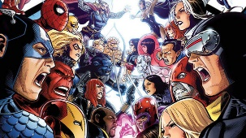
Our topic for this half term is called ‘Heroes and Villains’. This will involve creating a game on Scratch. Feel free to log in to Scratch over the half term to learn all about how to use it. The link is: https://scratch.mit.edu/ideas .

Music and P.E
Brass will continue to be on Wednesday afternoons with Mr. Jones and Miss Arnold. P.E. will continue to take place on a Friday afternoon. Please be aware that the weather will, hopefully, begin to improve so please send sun cream, hats and water bottles.


End of year show!
We are excited to announce that this year we will be doing The Amazing Adventures of Super Stan! After this term’s assessments, we will begin auditions and casting. All children are welcome to audition for all roles. All roles will be fairly decided with the children – we can’t wait for a super end to the year.

Homework – A reminder!
There are weekly spellings, MyMaths and Times Tables Rockstars tasks to complete. We also have a homework book that will have a weekly activity for the children to do, this activity will vary from week to week. It will be due in on a Wednesday and new homework will be sent out on a Friday. Please continue to read regularly with your child as it helps to develop their English skills massively; it will boost their comprehension, word reading and widen their vocabulary.
Year 6
As you are aware, the Year 6’s will be sitting their end of year exams on the week commencing Monday 13th May 2019. They have worked fabulously all year and this will be an opportunity to showcase their excellent work. It is also an opportunity for the children to have an extra breakfast!

