Autumn Term Two Newsletter
Welcome back after a lovely week off! I hope you had lots of fun. This half term is jam packed with exciting learning and fun experiences! As always, if you have any questions do not hesitate to ask Miss Rouke.

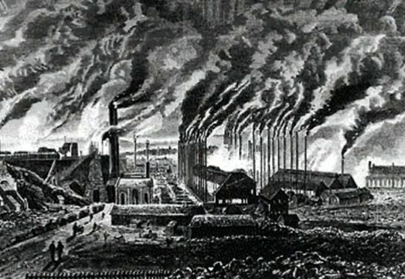
Topic
This half term’s topic is the Industrial Revolution. This will involve learning about why the Industrial Revolution was important to Britain; the significance of cotton spinning – this will include a trip to Belper Mill; the importance of steam engines; the impact coal and iron had on the Industrial Revolution and why the train lines influenced Britain so much. In Art, we will be looking at the artist William Turner. He was an artist who produced art in reaction to the Industrial Revolution. We will head down to the canal and do our own drawings of the canal. We will also be taking a trip to Belper Mill to learn about the cotton industry.
English
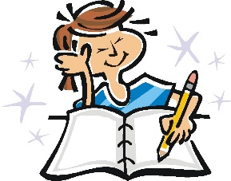
In English, this half term, we will be looking at different genres of writing and they will link to our Topic or to the time of the year (Christmas!). These genres will include a persuasive text – either an advert or leaflet; a newspaper from the industrial revolution times and a character description. In addition, we will be covering a multitude of spelling, punctuation and grammar topics to build sophistication in their writing.

Maths
In Maths, we will be covering a range of topics that include shape – 2D and 3D; fractions; decimals; percentages and ratio! We will build on the number work we have done in the previous half term, therefore, please continue to practise times tables at home. The focus will be to develop confident mathematicians, who enjoy doing maths!
Science
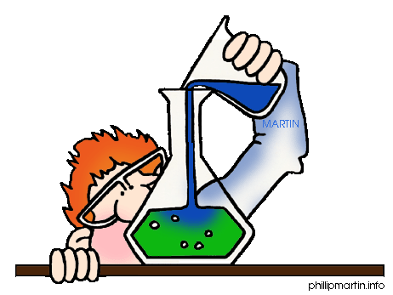
This half term, we will be learning about Materials. Where possible, this will link to our Industrial Revolution topic. We will be carrying out lots of science experiments, such as thermal conductivity of materials; reversible and irreversible changes; electrical conductivity of materials and more! We will be focusing on what makes a fair test and ensuring that we are working scientifically. Keep an eye on our class page to see the awesome experiments!

R.E. and Computing
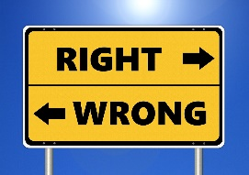
In R.E., we will be attempting to answer the question: ‘What can we learn from religions about deciding what is right or wrong?’ This will also link to our Industrial Revolution so we will debate around whether the industrial revolution was a good or bad thing to happen to Britain.
Our Computing topic from this half term will also link to Topic, and we will be creating ‘Cars’. This will be an opportunity to program and design our own games with cars!

Music and P.E
Brass will be on Wednesday afternoons with Mr. Jones. P.E. will take place on a Friday afternoon. Please be aware that the weather will begin to cool off, therefore, send jumpers and long bottoms where possible.

Homework
There are weekly spellings and homework book tasks to complete. It will be due in on a Wednesday and new homework will be sent out on (or before) Friday. If your child has any problems with the homework, then please ask them to come and see Miss Rouke (before hand in day) to have the homework explained again. Please continue to read regularly with your child as it helps to develop their English skills massively; it will boost their comprehension, word reading and widen their vocabulary.

