DRUMMING
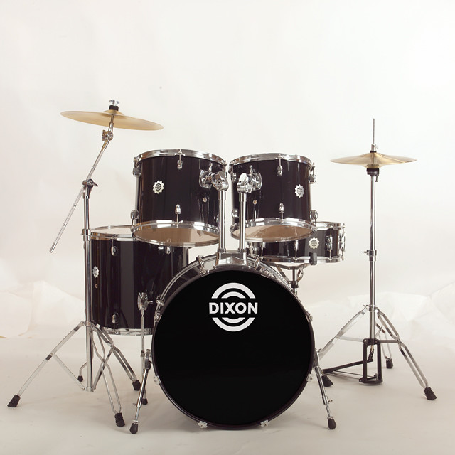
Drumming (a musical form which was created in 500BC) is a great skill to have. It can help with many different matters other than entertainment such as: letting out anger, helping to control chronical pain and strengthening your mind. The first drum kit ever to be played was invented, originally, from China before it was shipped world-wide. Most bands have begun to include the drums as it is proven to attract more people, especially tourists, to concerts.
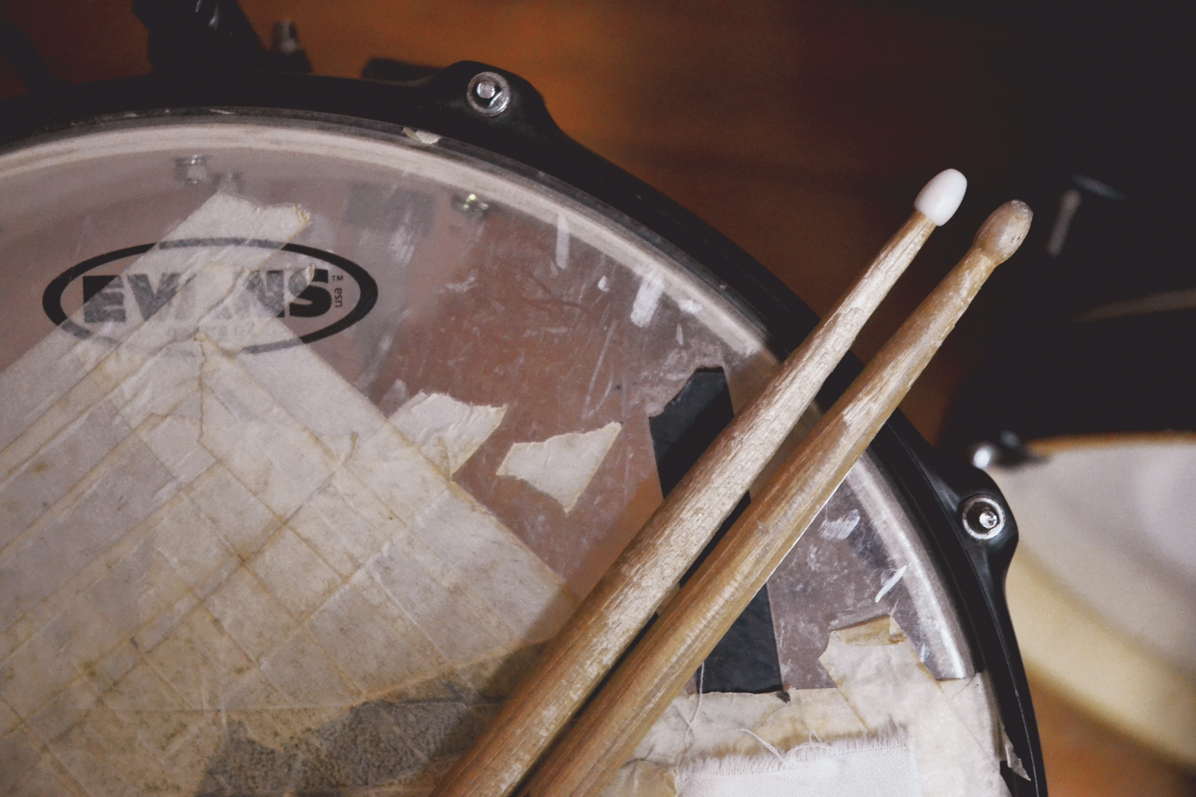
Famous drummers around the world
Many well-known drummers started just practicing drumming as a hobby but have grown to become world-famous. There are numerous drummers whose names are everywhere but only few will survive the generations. There are plenty new 20th century drummers including: John Bonham, Dave Grohl, Travis Barker and Keith Moon but none are as eminent as Buddy Rich (an American jazz drummer and band leader.) He lived a long life of (9.30.1917-4.2.11987.)

Drumming today
Drumming is an instrument made up of rubber, and silicone (or if an acoustic birch and maple wood) and other resources. There is a screen a lot like the drums called a drum pad. The drum pad is used to tap and create different sound with each button. It became popular during the 1920s and was enjoyed by people all over the world.

Did you know?
The first drums where made out of natural resources such as: alligator skin ,cow fur, snake skin and even tree bark. The first band to include drums was the original Dixieland Jazz band.

