Marvel
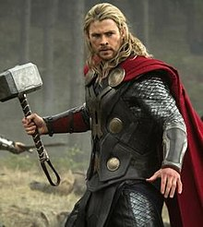
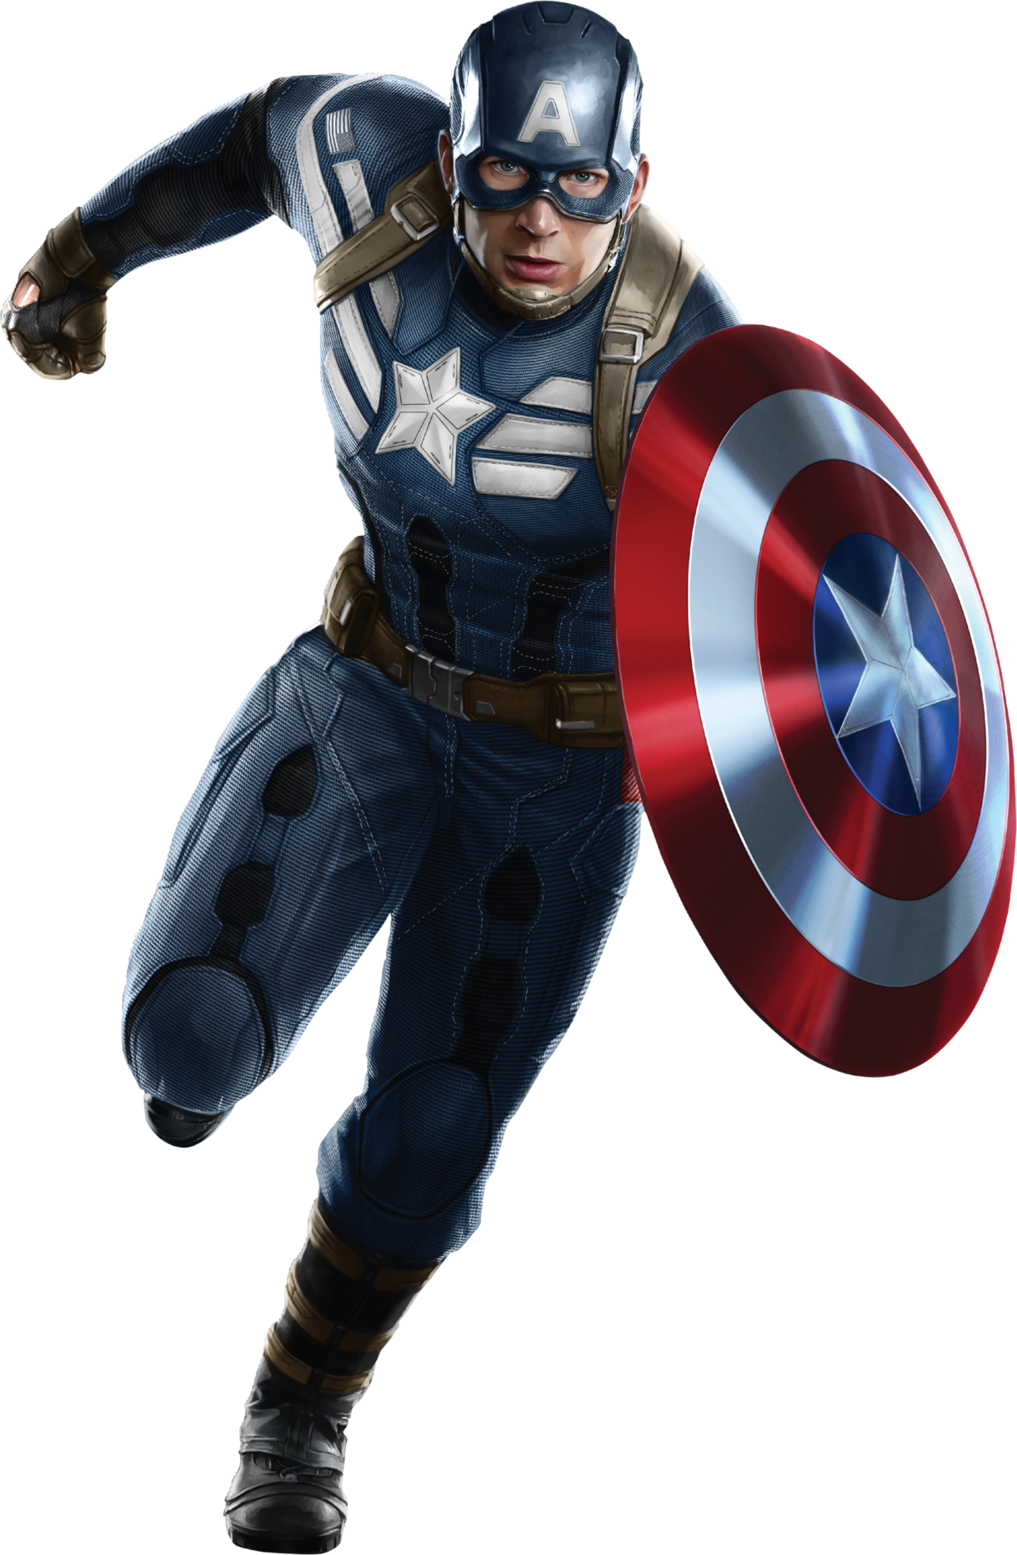
Fun Fact!
Only those who are worthy can pick up Thor’s hammer.
Basic Knowledge
Most people know the first avenger as Captain America but I recognise the first avenger as Captain Marvel because she was the first person that Nick Fury saw that had super powers. Two more battles are: Magnog Vs Thor and Odin and the Immortal Hulk Vs the Abomination.
The characters and their powers
Clint (Hawk Eye): He has really good aim and serval strange arrows.
Banner (Hulk): whenever he gets angry he turns into a green giant and he can’t die.
Natasha (Black Widow): She is really good at self-defence like boxing.
Wanda (the scarlet witch): She’s a witch.
Tony (Iron man): He has a suit which is kind of like a robot skin.
Steve (Captain America): He got injected with a super serum which then gave him super strength.
Thor: He is the god of lightning.
Loki: Loki is the brother of Thor and god of mischief.
Ultron: Ultron is a suit that Tony made that went wrong and began trying to kill him.
Marvel was first founded in 1998, New York, United States of America. Even though Marvel is quite old, it’s still known all over the world solely for its X-men and Avengers. Some of the epic battles include: the battle for the galaxy and the battle for a Titan.
The Avengers
Only those who The Avengers are a fictional team of super naturals put together by the shield (an agency) Nick Fury. The name was originally going to be the protectors until Brie Larson (the actress for Captain Marvel) suggested the well-known name: The Avengers.

Characters that get ignored
Pièdro, Bucky, Ultron, Drax, Gamora, DR strange, Vision, Ant man and wasp

