Apex Legends
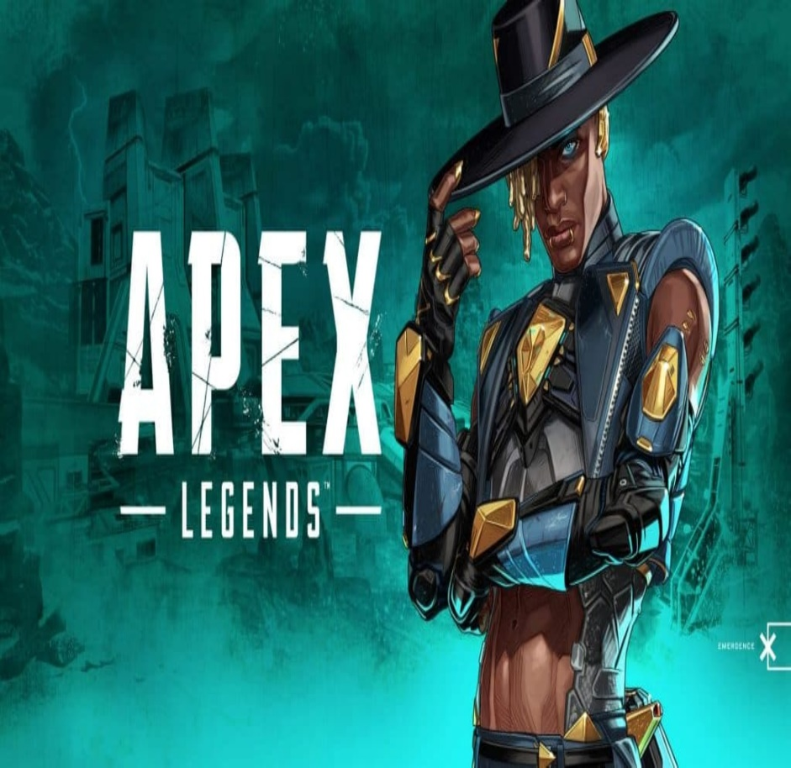
Apex legends (a computer game) or otherwise known as wild frontier. Is a battle royal based game where you use characters and their abilities along with guns to be the last team (or last man) standing. It was made in 2019 by two companies called electronic arts and respawn entertainment, making kids stay inside and pay money to buy apex tokens (in game currency).On the other hand, it can be fun you can make new friends and play with friends.
What is Apex legends?
Respawn entertainment and electric arts (the creators of Apex) created a sequel of Fortnite, Apex legends didn’t copy though answering the question did Apex legends copy fortnite
How to play apex legends?
There are many consoles you can use to play apex legends including: Xbox, PlayStation, pc and mobile. In Apex legends there are characters ranging from octane to Watson to loba and more with all different abilities. Different games include: Halo, Fortnite and pubg. Parentally in the future Apex is going to be a vr game. Also the buttons you use are: slide, sprint, aim, shoot, swap, and pick up, select and next.
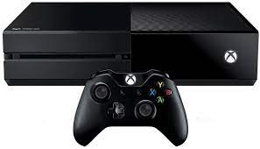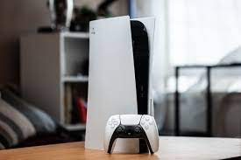

What are the guns in apex legends?
There have been many guns in Apex Legends some have come and gone and some have never been taken out of the game. Some are rapid fire and some shoot slower. These include: The Bokek, C.A.R, re.45 and more. Also, since more people play Apex more characters are added some doing bonus damage with specific guns. The best place to get guns is called the bunker, sadly you need a key card to access it though.

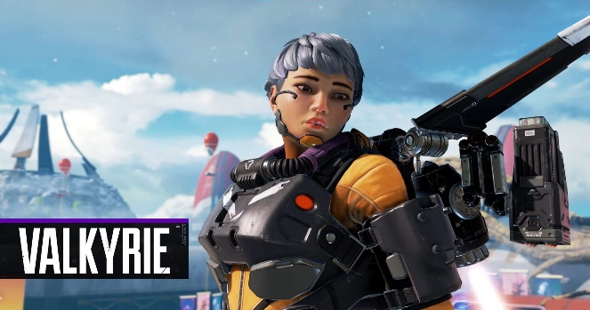
What are the characters in Apex Legends?
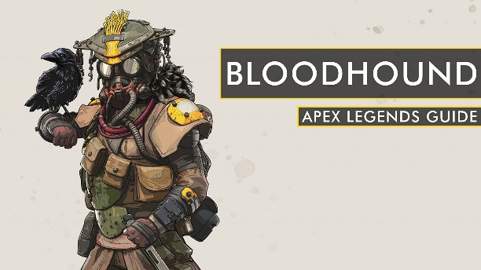
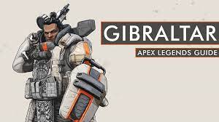
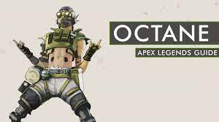
Apex Legends has many characters has many characters al different from each other. Some have offensive abilities and ultimates and some have defensive abilities and ultimates. Some include: caustic, revanant, Ash and many more. The best defensive characters are bloodhound and Gilbratar. Also, the best defensive are octane and Valkyrie.
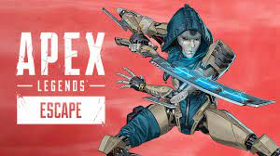
<- Ash.


