Horses
Horses have been used for over 3500 years, they have become more popular over the last few years. Having a bond with a horses can grow: trust, respect and confidence. In the olden days they were used to go down mines and pull carts now people are a lot more creative people: go to show on them ride , have lessons , do jumping, or poles, they can have a picnic with them, take them on a walk, hang out with the horse and let them play in water.
Horse care is very important to keep your horse healthy and happy, horse care includes: looking after them, making sure they have food and water and grooming. The Romans were the first to discover the horse shoe (put on a horse shoe in 400BC). The proper name now is a farrier. Some horses wear shoes to protect their hooves, however wild ponies/ horses do not have shoes, so after a while their hoof will come off and they will grow another. The name ‘horse’ came from hipposandles, hippo mean under water horse and sandles means shoes.
Horse Care

Grooming is important but in winter you should not brush your horse because it causes the horses/ponies winter coat (fur) to come off, when it’s muddy you should pick their hooves more often. They are used for: fun, shows and long distances. In the future horses might still be ridden but there could be robots to groom and tack up the horse, they were popular in 2000BC and onwards but today they are very popular and a lot of people are getting horses.
Grooming

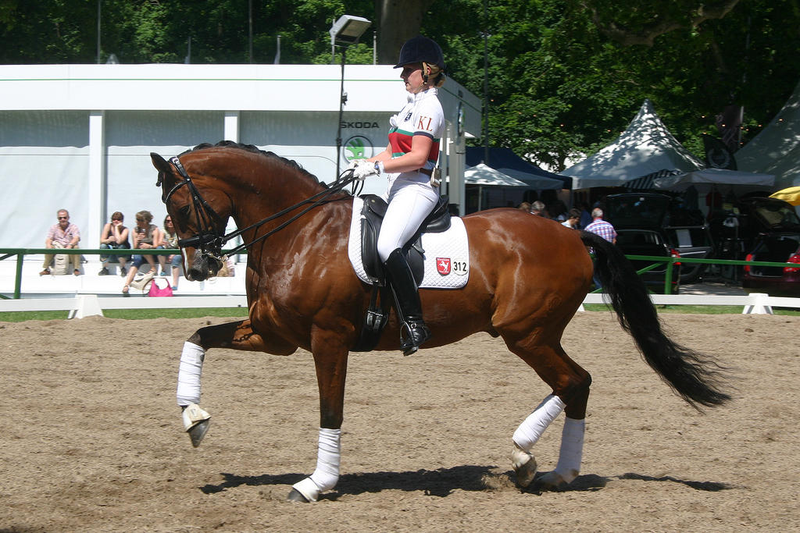
A lot of people ride a horse when its lame but it causes pain. The first person/people to cure lameness was a man with a lot of ponies and horses. After his success he became a vet, after a horse is lame you cannot ride it. After a few days and your horse or pony looks better, you can slowly bring it back into work.
Can You Ride A Horse When It’s Lame?
Shows

[Sidebar Title]
[Sidebars are great for calling out important points from your text or adding additional info for quick reference, such as a schedule.
They are typically placed on the left, right, top or bottom of the page. But you can easily drag them to any position you prefer.
When you’re ready to add your content, just click here and start typing.]
bbb

You can take horses and ponies to many different shows such as: barrel racing, western riding, jumping , dressage and much more .Fun fact horses can actually sleep sitting down and standing up!
Shows

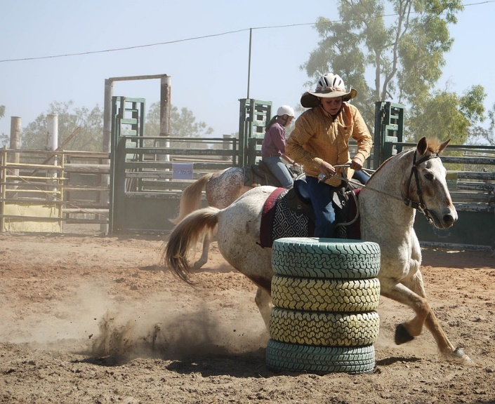
Barrel racing dressage

