SURVIVAL SKIILLS

Survival is an adventure it will guide you to places you’ve never visited or seen before. It’s a great activity if you’ve not been outdoors for a while. Secondly, it’s a way of staying alive in a natural environment.
Survival Kit List
- First Aid
- Shelter (1 man)
- Water
- Adventure food
- Sleeping bag
- Emergency rain coat
- Pots and pans
- Hiking backpack
- Flask
- Light
- A filter
- Navigation
- Mind ready
- Matches
- Pocket knife

- a

Famous Survivalists
- Dave Canterbury has got 20 years of combined military and civilian survival skills.

- Ray Mears (a British woodsman and instructor) is a notorious among survival personalities

- Mykel Hawke is a U.S army specialist

- Les Stroud has got a T.V show called Survivoman. Meanwhile, he’s a Canadian survivalist

BEAR GRYLLS
Most common type of rescue

- Hiking ~ 48%
- Boating ~ 21%

Types of Accidents
- Hiking ~ 22.8%
- Climbing ~ 12.1%
- Swimming ~ 10.1%
- Boating ~ 10.1%

Bear Grylls is a T.V sensation. He had a real hunger to survive from a young age. He grew up in London (7 June 1974) with a sister called Lara she named him bear from 3 weeks old. Bear Grylls is 47 and his full name is Edward Michael Grylls.
Secondly, in karate he got a black belt.

Did You Know?


When you realize you are lost you should stop. Stop means:
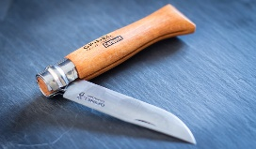
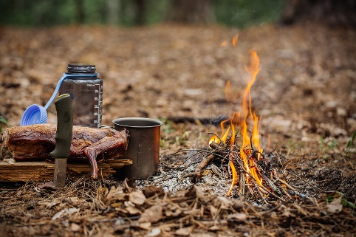
Stop
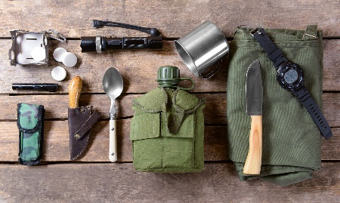
Think strategy’s
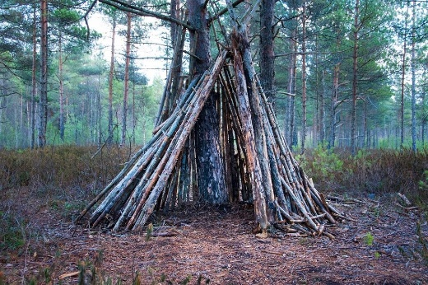
Observe surroundings

Plan for survival by gathering material

