Bloons TD 6
Bloons TD6 is a tower defence game made by Ninja Kiwi on the 14th of June 2018. It is designed to be easy to play and fun.

Early Games
In your first games you should stay on easy, primary only, deflation and medium but don’t try hard or any special medium modes expect military only, for apopolypse is too hard to play in the start of the game before you have monkey knowledge.
Exp, Upgrades and Tier 5s
As you play, you unlock upgrades to make your monkeys stronger these upgrades require an Exp unlock cost and an in-game payment every time you want to upgrade to it. Eventually you will unlock an upgrade that is hidden these are T5s the strongest upgrades in the game. But, you can only get one of each (with the notable exception of the 2 crossbow masters if you have the double cross monkey knowledge) per game.
Bloons, MOABs and Boss Bloons
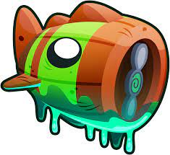
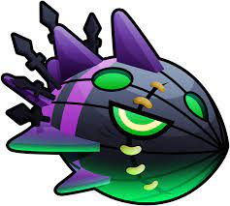
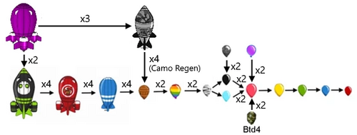
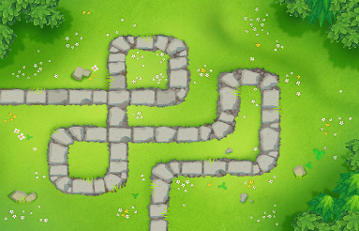
The monkeys’ enemies’ the Bloons are the opposition they follow the map path (or paths) and if they get to the end you lose lives. To stop them getting to the end you have to place monkey towers to pop them. After the Bloons come MOABs the stronger variant of Bloons and if you go into boss events you can encounter Bloonarius and Lych the game’s bosses. This is all you need to know to beat the listed difficulties.

Bloonarius Lych

