Transport and its inventions
20th Century
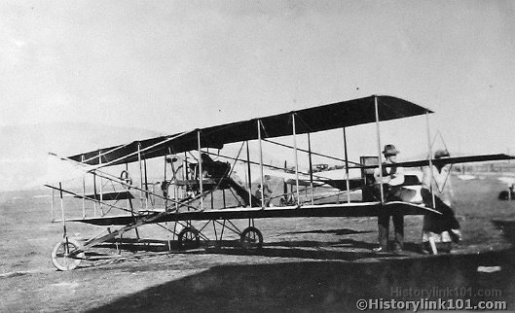
lo9.The 20th century lasted for 100 years (between 1900 and 1999). This century made big steps in technology, travel and medicines. The first decade was important for travel and technology, with the first plane in 1901, which flew for 30 minutes before landing. Its inventors, called the Wright brothers, made the first plane. After trial and error, it finally worked. If it wasn’t for the first plane, transport wouldn’t be the same today. Four years later, the Ford model T was invented (by Henry Ford). This was a key development in engine transport – it changed the way for cars to be made. One automobile could be made per hour. It was the best quality automobile of it’s time, and cheapest car, making Ford an ideal brand for customers.
Key events
Titanic sinking 1912
WWI 1914-1918
Great Depression 1928-1932
WWII 1939-1945
Cold War 1948-1993
Vietnam War 1959-1971
Falklands War 1982
Fall of the Soviet Union 1993

Famous People
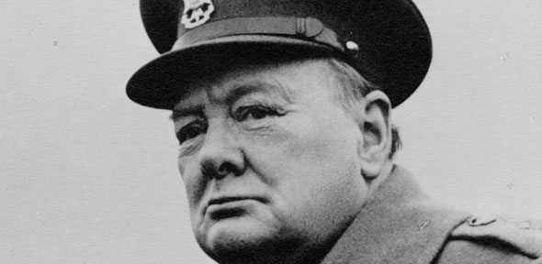
On the 17th of February 1915, Winston Churchill (born November 30th 1874 –January 24th 1965) commanded the invasion of Gallipoli. It ended on the January 9th 1916. The Australian Light Horse division invaded the Ottoman-held with no victor declared after the fighting. In 1940, he got elected as Prime Minister of the United Kingdom, after Neville Chamberlain, during the second world war, and ordered key events such as the Omaha beach landings on June 6th 1944. He left office in 1945 as a war hero.
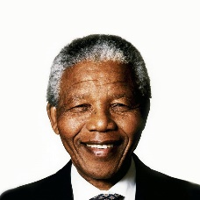
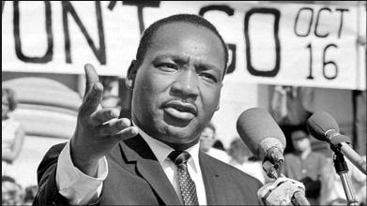
Martin Luther King (January 15th 1929 – April 4th 1968) led the civil rights movement during the 1960’s in the United States. It was aimed at stopping the discrimination in America. He was later assassinated on April 4th 1968 during a speech. Until today, he is highly regarded as an important figure in modern US history.
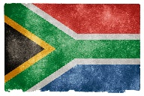
Nelson Mandela was born in South Africa (July 18th 1918 – December 5th 2013). He was a major force against discrimination in South Africa in the eighties and nineties but was trialed and later sentenced to prison multiple times. After many years of peace, he died in 2013 to old age. In honour of him and his life, he also has he own flag which is often called the “rainbow nation”.

