The Beginning of Computers

Computers (which were made in 1943) are very popular these days because they can be helpful for online questions you might want to keep a secret. Although they can be a little dangerous don’t worry, as long as you keep lock on your device you should be safe. It would be hard to imagine a world today without computers.

Who Discovered Computer?

Charles Babbage, a wizard at engineering, was the first person to make the modern computer. In those days computers were mostly incredibly expensive. Around twenty four years later they became less expensive but not too much. Although if you think about it computers are very helpful for everyday jobs such as; teaching, searching, work making and engineering.

Use of Computers.

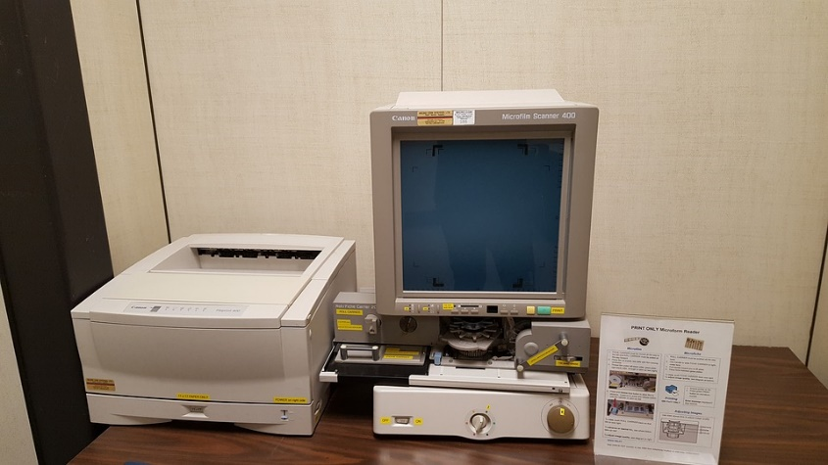
Computers (very useful devices) are used everywhere in the world. The computer has many things related to it such as: iPhone, iPad and interactive boards, although all of these things sound interesting they didn’t come out until around the 1970s when computers became popular. Computers might be used far more in the future for lots more jobs.

