VR

VR headset was made in 1968 in a basement. The main goal of VR is to put you in a different relate with not felling in it. It has affected life today by making new friends and sometimes fight .VR, when some people have motion sickness, can get motion sick very easy in VR to being daisy and run in to a wall or TV.
Who Made VR

VR (a VR headset) has gone for 53 years the first VR headset was made by Bob Sproul he came up with the name VR because it short for virtual reality. It has affected lot of people today by making people: make friends, felling like an assai or staying in it for 24 hours.
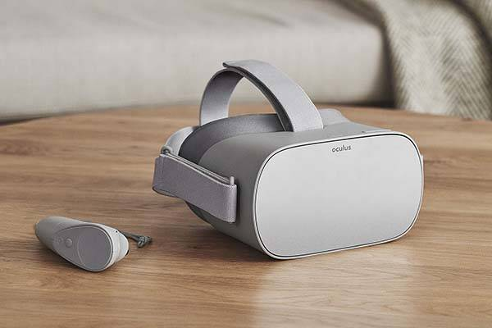

Other Uses For VR

VR (virtual reality) cannot gust shot a person in the leg then then body then the head but can help you do work . It became popular in the 1999 but no controllers. VR can help you do stuff like being sweaty and burn calories with you not knowing in a game
What is VR?

VR has gone on until 1959 so a lot of headsets have been made one of the most success full being the h3vibe a big collate headset the prise being at £700 to £950. VR has not reached the end of its making it might be in in 2098 we do not now.
Facts about VR

VR has many of game like; beat saber, a song blocks game has 5 different category’s of songs.


