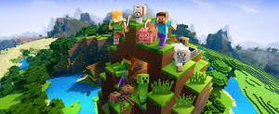
Mincraft

In Minecraft, players explore a blocky, procedurally generated 3D world with virtually infinite terrain, and may discover and extract raw materials, craft tools and items, and build structures Depending on game mode, players can fight computer-controlled mobs, as well as cooperate with or compete against other players in the same world. Game modes include a survival mode, in which players must acquire resources to build the world and maintain health, and a creative mode, where players have unlimited resources and access to flight. Players can modify the game to create new gameplay mechanics, items, and assets.

How Minecraft was made

Minecraft is a sandbox video game developed by the Swedish video game developer Mojang Studios. The game was created by Markus "Notch" Persson in the Java programming. Following several early private testing versions, with Jens Bergensten then taking over development. Minecraft has since been ported to several other platforms and is the best-selling video game of all time, with over 238 million copies sold and nearly 140 million monthly active users as of 2021. Minecraft has been critically acclaimed, winning several awards and being cited as one of the greatest video games of all time. Social media, parodies, adaptations, merchandise, and the annual Minecon conventions played large roles in popularizing the game. The game has also been used in educational environments to teach chemistry, computer-aided design, and computer science. In 2014, Mojang and the Minecraft intellectual property were purchased by Microsoft for 2,097,787,500 Pounds. A number of spin-off games have also been produced, such as Minecraft: Story Mode, Minecraft Dungeons, and Minecraft Earth.

How to play Minecraft

The first thing you need to do is dolownod Minecraft and then click on crate new world and click crate if you can change settings or game mode. You are dropped into a large randomized open world (actually infinite!) with biomes such as mountains, forests, caves, plains and oceans - with no specific goal or objective. Progression can only be reached through an Achievements system. The world consists of blocks, which you can destroy, remove, build or replace. It also has a night/day cycle. Depending on the set difficulty level, players need to eat and defend themselves from hostile mobs during the night. Through various Game Modes chosen at the start of each new game, players will experience a different adventure. If you just want to focus on building amazing things, you should choose Creative Mode. If you want a real adventure, boom, Adventure Mode is for you. If you want a harder day use survival, Survival Mode is the perfect fit. These various modes makes the game even more repayable.

Mobs

Mobs are a vitel pert of the game A mob is an AI-driven game entity resembling a living creature. The term "mob" is short for "mobile entity". All mobs can be attacked and hurt (from falling, attacked by a player or another mob, falling into the void, etc.), and have some form of voluntary movement. Different types of mobs often have unique AI and loot.
Passive mobs are harmless mobs (except for pufferfish) that do not attempt to attack the player, even when provoked or attacked. Most of them can be bred or tamed.
 |  | 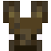 |  |  |  |  |  | 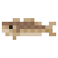 |  |  |  | 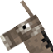 |  |  | 
Axolotl |  | Bat |  | Cat |  | Chicken |  | Cod |  | Cow |  | Donkey | Fox |  | Glow Squid
 |  |  | 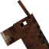 |  |  |  |  |  |  |  | 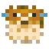 |  |  |  |  | 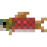
Horse | Mooshroom |  | Mule |  | Ocelot |  | Parrot |  | Pig |  | Pufferfish (defensive) |  |  | Rabbit |  | Salmon

 |  |  |  | 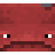 | 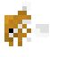 |  |  | 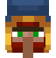
Sheep | Skeleton Horse | Snow Golem | Squid | Strider | Tropical Fish | Turtle | Villager | Wandering Trader

Neutral mobs
Neutral mobs are sometimes passive and sometimes hostile toward the player. All of these mobs (except goats) are provoked when player attack it first. Some mobs may also be naturally hostile with provocation, and some mobs also have some additional way to be provoked.
 | 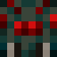 |  |  |  |  |  | 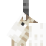 |  |  |  |  | 
Bee | Cave Spider |  | Dolphin |  | Enderman |  | Goat |  | Iron Golem (naturally spawned) |  |  | Llama
 |  | 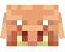 |  |  |  | 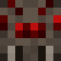 |  |  |  |  | 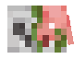
Panda |  | Piglin |  | Polar Bear |  | Spider |  | Trader Llama |  | Wolf | Zombified Piglin

Hostile mobs
Hostile mobs are dangerous, aggressive mobs that always attack the player within their respective detection ranges. Some passive mobs such as chickens and skeleton horses can be hostile if ridden by a hostile mob on rare occasions.
 |  |  |  |  |  |  | 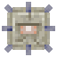 |  |  |  | 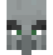 |  |  |  | 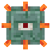 |  | 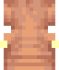
Blaze |  | Chicken Jockey |  | Creeper |  | Drowned | Elder Guardian |  | Endermite |  | Evoker |  | Ghast |  | Guardian |  | Hoglin
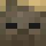 |  |  |  |  | 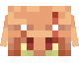 |  |  | 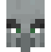 |  | 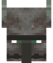 |  |  |  |  |  |  | 
Husk | Magma Cube |  | Phantom |  | Piglin Brute |  |  | Pillager |  | Ravager |  | Shulker |  | Silverfish |  | Skeleton | Skeleton Horseman

 |  |  |  | 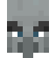 | 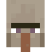 |  | 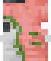 |  | 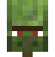
Slime | Spider Jockey | Stray | Vex | Vindicator | Witch | Wither Skeleton | Zoglin | Zombie | Zombie Villager
Most undead mobs have the ability to pick up items. Some can spawn wearing armor, or holding tools or weapons

Boss mobs
Boss mobs are special hostile mobs that are distinctly more dangerous and tougher than other mobs. They do not spawn randomly, and are confronted intentionally. All of them also have a boss bar featuring their name and health. Boss mobs provide unique challenges but also equivalent rewards.
 | 
Ender Dragon | Wither

Deleted mobs
Mobs that were announced by Mojang as confirmed, mentioned or potential future additions, but either got replaced by other mobs or scrapped.
These mobs either:
- Were said to not be added in a future update (the mobs that lost the MINECON Earth 2017 mob vote)
- Were said to have a possibility of being added in a future update (the mobs that that lost the Minecraft Live 2020 and Minecraft Live 2021 mob votes) Are not known to be under consideration for a future update (the Red Dragon and the mobs that lost the China Edition mob vote)
 |  | 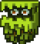 | 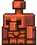
Moobloom | Iceologer | Glare | Copper Golem
.

Extrerers

