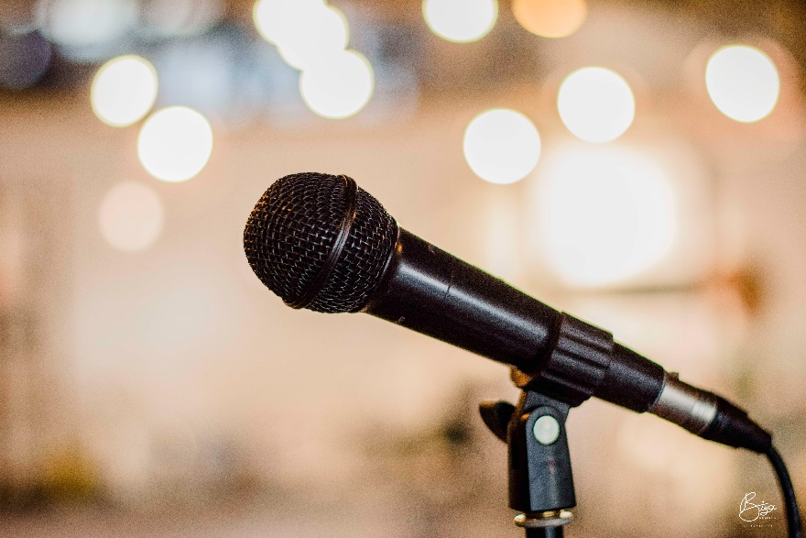
SINGING!

Singing started over 530,000 years ago. The first person to be recorded singing was Edouard-Leon Scott de Martinvill the song lasted 20 seconds on the 9th of April 1860. Singing is a very big part of life today we have it all over the world. It is in different languages so everyone can listen, people use music for joy, pleasure and talent.
INTRODUCTION

Singing was a big part to lots of people’s lives. The word singer came from the German word sanger. Singing has developed over centuries, it has backup music.
THE BEGINNING OF SINGING

There are many people who can sing. Then there are famous ones such as: Victoria Justus, Ariana Granda, Ed- Sheran and Sia. These are all famous singers, they go on tour and do shows they have a benefit to others.
FAMOUS SINGERS

Holly Humberstone is a newly relied singer with a lot of pure talent. She has got a lots of songs such as: Drop Dead, Vanilla, The Walls Are Way Too Thin, Haunted House and Green Plastic Watering Can’s. She is known by lots of people maybe all over the world.
HOLLY HUMBERSTONE

When singing you can go to shows and events and win medals and trophies. Singing is one of the worlds first of many talents. These people are some famous singers: Piper Rokell, Cold Play, Little Mix, Jenna Davis and Bella Porch.
DID YOU KNOW?

