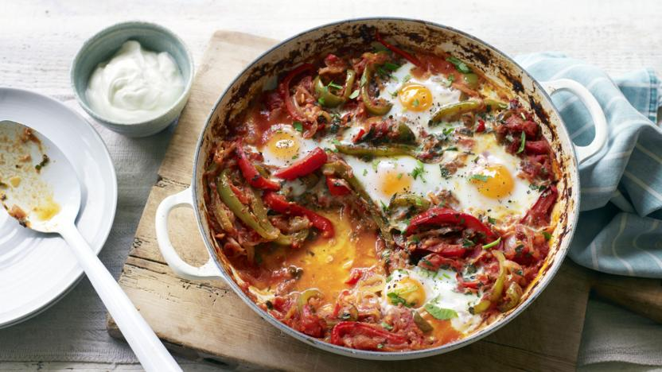
Shakshuka

Shakshuka is an incredibly easy baked egg recipe that works just as well for brunch as it does for dinner. Smoky, sweet peppers combine with rich, creamy eggs, tangy yoghurt and salty feta for a completely moreish dish.
Each serving provides 462 kcal, 26g protein, 28g carbohydrates (of which 25g sugars), 25g fat (of which 8g saturates), 8.5g fibre and 1.4g salt.

Preparation time  less than 30 mins | Cooking time  10 to 30 mins | Serves  Serves 4

Ingredients
- 3 tbsp olive oil
- 2 large onions, thinly sliced
- 2 red peppers, cut into long slices
- 2 green peppers, cut into long slices
- 4 garlic cloves, finely chopped
- ½ tsp cumin seeds
- ½ tsp caraway seeds
- ½ tsp cayenne pepper
- 1 tbsp tomato or red pepper purée
- 2 x 400g tins tomatoes
- 1 small bunch fresh coriander, roughly chopped
- 1 small bunch fresh parsley, roughly chopped
- 8 free-range eggs
- 85g/3oz feta, crumbled
- 8 tbsp thick natural yoghurt or labneh
- salt and freshly ground black pepper

Method
- Heat the olive oil in a large, lidded frying pan. Add the onions and peppers, and season with salt and pepper. Cook on a medium heat until just softened. Add the garlic and cook for a further 2 minutes. Sprinkle in the cumin and caraway seeds and the cayenne pepper. Stir in the tomato or red pepper purée and cook for a couple more minutes until the paste starts to separate. Add the tomatoes with a splash of water.

- 2. Simmer for 10 minutes, uncovered, until reduced a little. Taste after 5 minutes and add a little sugar if you think the tomatoes need it. Keep an eye on the texture – you don’t want it runny, but it mustn’t get too dry, either. Add another splash of water if necessary. When the sauce is reduced, stir in the herbs.

- 3. Make 8 small wells in the sauce. Break an egg into a cup and drop carefully into a well, repeat with the remaining eggs. Cook for a few more minutes until the whites are just set and the yolks are still runny. Sprinkle over the crumbled feta. Serve with yogurt or labneh on the side.

Recipe Tips
It might be difficult to find space for 8 eggs in one large frying pan. At this stage, the sauce can be divided between two pans.
Add 100g of kale or rainbow chard when you cook the onions for an extra vegetable boost

